2014 U3 AOS 2 Outcome 2 -Solution

Question 3
The production of bioethanol is represented in the flowchart below:
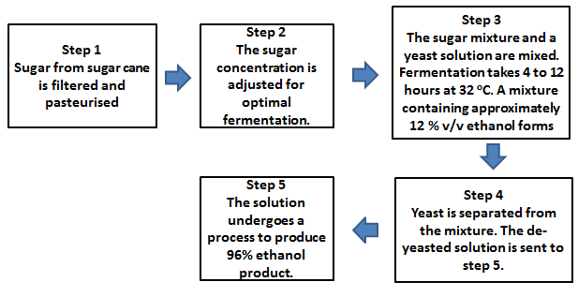

(i) Write a balanced chemical equation for the fermentation process occurring in bioethanol production. Assign states to the reactants and products.
C₆H₁₂O_{6 (aq)} → 2CH₃CH₂OH _{(aq)} + 2 CO_{2(g)}
1 mark for balanced equation and 1 mark for correct states.

(ii) Ethanol is miscible with water whereas octane is not. Use your knowledge of intermolecular bonding to explain why this state is true.
- Ethanol is a polar molecule which is able to hydrogen bond with water molecules and so is able to dissolve 1 mark
- Octane is non-polar and so does not mix with polar water molecules. Only weak dispersion forces exist with the water molecules 1 mark
(iii) Describe one limitation in the efforts to produce large quantities of bioethanol for use as a fuel
- The use of crops for food outweighs their value as a source of bioethanol or
- There is not enough land to grow crops for fuel 1 mark
b) An alternative method of production of ethanol is shown below.
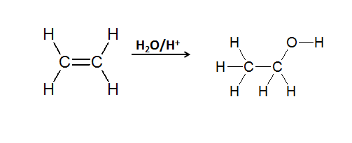
(i) Name the type of reaction shown in the equation.
Addition reaction or hydrolysis 1 mark

(ii) Would this ethanol be termed bioethanol? Explain your response.
No 1 mark.
This ethanol is produced from a petroleum product, which is non-renewable or this ethanol is not derived from a plant (living) source. 1 mark

Total = 8 marks

